

**KTO KARATAY UNIVERSITY FACULTY OF ENGINEERING MECHATRONICS ENGINEERING**

ROBOTICS (MEM-720)

<27.12.2024>

**Name** : Mustafa USTA

**Student ID** : 200313004

**Student ID** : Asst.Prof. Hüseyin ALP

**Teaching Assistant** : Res.Asst.Sinan İLGEN

**Working Area** : Adaptive Assembly System Project

**TABLE OF CONTENTS**

1. INTRODUCTION 1
   1. Objective 1
   2. Research and Implementation Methods Used… 1
2. PROJECT 2
   1. Adaptive Assembly System. 2
   2. Fields of Use 3
   3. Model Circuit Schematic 4
   4. Operation Algorithm 4
   5. Robot Codes and Locations 5
      1. System Locations… 5
      2. Robot Codes… 5
   6. System Microcontroller’s Codes 7
3. REFERENCES 9

# INTRODUCTION

Automation systems are an important technology in modern industries aiming to increase productivity by reducing labor. In this project, an automation system is designed in which a conveyor belt system and a robot arm are integrated. The project is based on detecting and classifying products of different sizes and performing appropriate operations. The system is a complex mechatronic application where sensors, microcontrollers and robotic elements are used together.

## Objective

The main objective of this project is to automatically detect the various products being transported on the production line and guide them with robotic operations within the framework of a production scenario designed for the product. Thus, it is aimed to reduce human intervention, error margins and costs by automating product classification, quality control and handling processes on production lines.

## Research or Implementation Methods Used

Various research and implementation methods were adopted for the successful completion of the project. These methods were selected and applied in order to achieve the project's objective and solve the problems effectively.

### Utilization of Internet Resources

During the project process, internet resources were utilized to obtain information on various topics and to access existing solutions. These resources have played an important role in keeping up to date with current developments in the project area, evaluating the experiences gained from similar projects and finding solutions to the problems encountered. [2]

### Article and Thesis Reviews

In order to strengthen the theoretical foundation of the project and integrate knowledge from similar studies, various academic sources were reviewed. In this context, relevant articles, theses and scientific publications were reviewed to gain an in-depth understanding of the key issues of the project. This information was used to develop the methodology of the project and to evaluate the results. [3]

These various research and implementation methods contributed to the successful realization of the project and increased the reliability of the results obtained. These methods strengthened the scientific basis of the project and were used as an effective tool to achieve the objectives.

# PROJECT

## Adaptive Assembly System

The project was developed using Mitshubishi Industrial robotic arm. The working algorithm of the system can be summarized as follows:

1. **Triggering with Sensor:** The proximity sensor stops the system when it detects product on the conveyor belt.
2. **Product Measurement:** The size of the product is measured with sensors and the appropriate robotic scenario is triggered according to the measured distance.
3. **Robot Operation:** After the robot completes its operation, it informs the system with the “done” signal and the system is ready to work again.

### Technical Specifications:

* + **Industrial Robot Arm:** Mitsubishi CR750 2F-D Industrial Robot
  + **Sensors:** Industrial proximity sensor,
  + **Actuators:** Conveyor system
  + **Inputs:** 3 robot pins for different scenario

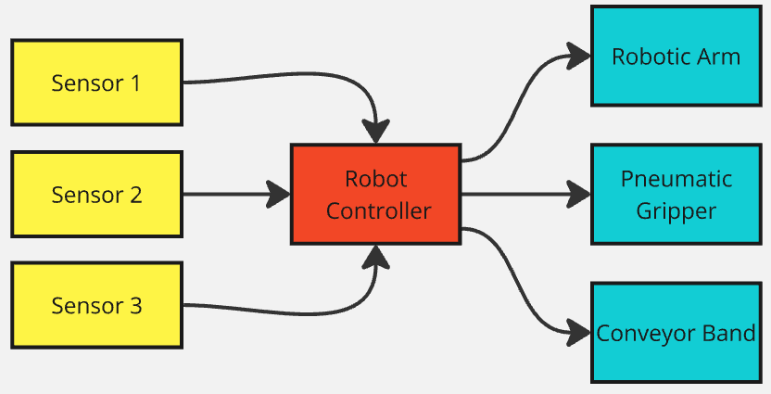

Figure 1. Industrial Automation System Operation Logic Demonstration

## Fields of Use

This system has various applications in the field of industrial automation:

* + **Production Lines:** Sorting and routing products of different sizes.
  + **Storage and Logistics:** Sorting products by size before packaging.
  + **Food Processing:** Sorting food products according to size.
  + **Quality Control:** Detecting and sorting defective or substandard products.
  + **E-Commerce:** Directing products to appropriate areas before storage and shipping.

The scalable nature of the project makes it possible to easily adapt it to other industries. These features enable the system to have a wide range of uses provides.

## Model Circuit Schematic

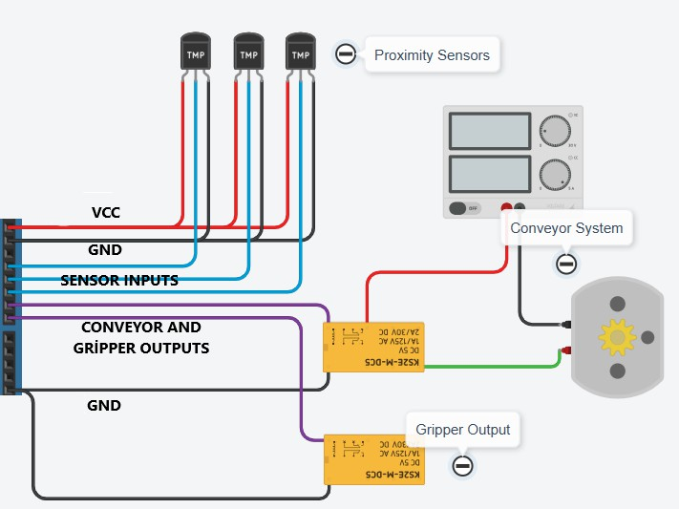

Figure2. System Schematic

## Operation Algorithm

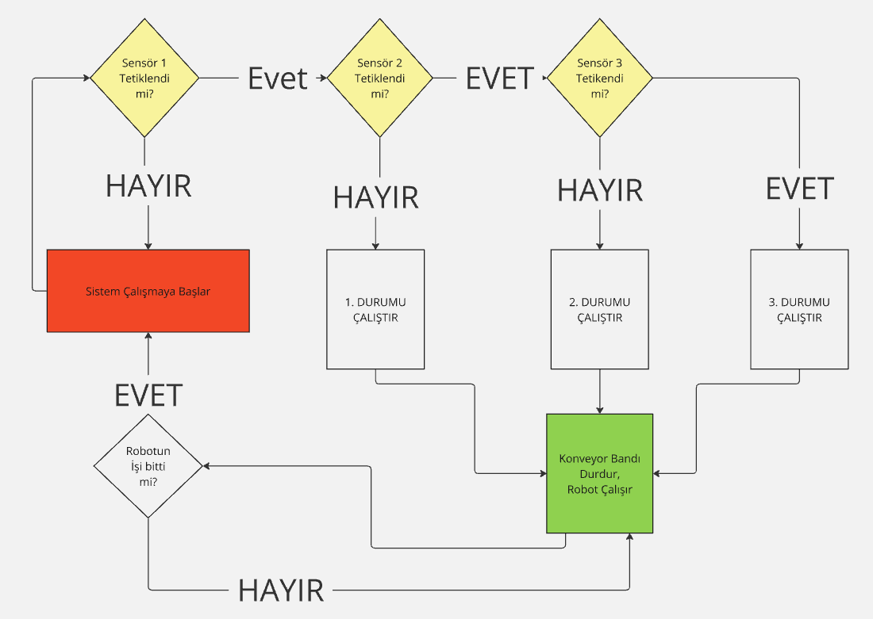

Resim 3. System Operation Algorithm

## Robot Codes and Locations

## System Locations

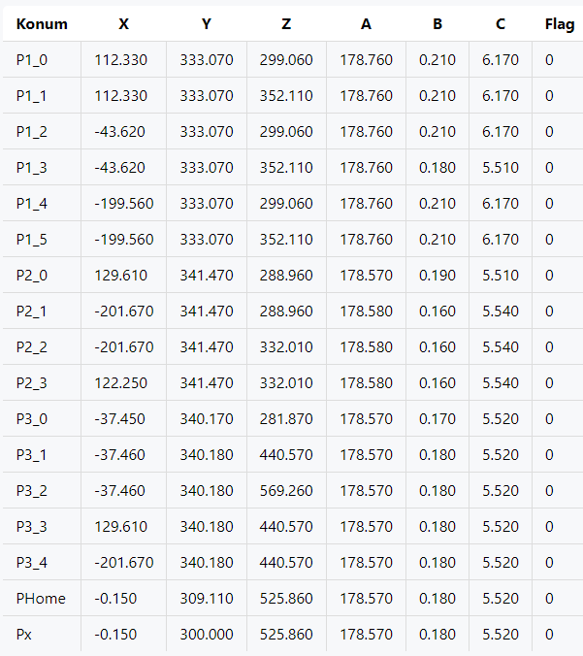

## Robot Codes

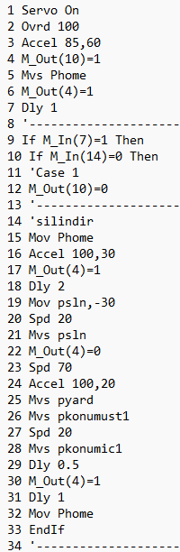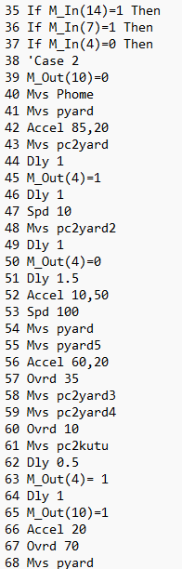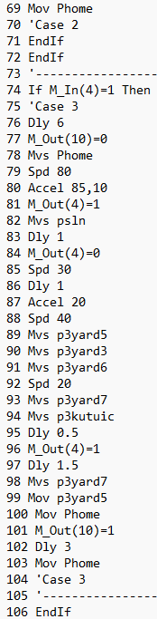

# REFERENCES

1. ADVANCED KINEMATIC CALCULATION METHOD FOR A FIVE-JOINT ROBOT

ARM<https://www.emo.org.tr/ekler/258b2257ce52929_ek.pdf>

1. Saeed B. Niko. Introduction to Robotics Analysis, Systems,Applications. NJ07458.

Robot Programming and useful documents related to robot:

* + [https://electrobit.ee/web/file_bank/Manuals/robotid/mitsubishi/cr751/CR750-CR751-CR760-setup-](https://electrobit.ee/web/file_bank/Manuals/robotid/mitsubishi/cr751/CR750-CR751-CR760-setup-operation-maintenance_ENG.pdf) [operation-maintenance_ENG.pdf](https://electrobit.ee/web/file_bank/Manuals/robotid/mitsubishi/cr751/CR750-CR751-CR760-setup-operation-maintenance_ENG.pdf)
  + [https://www.allied-automation.com/wp-content/uploads/2015/02/MITSUBISHI_CR750CR751-Controller-](https://www.allied-automation.com/wp-content/uploads/2015/02/MITSUBISHI_CR750CR751-Controller-Instruction-Manual-Detailed-Explanations-of-Functions-and-Operations1.pdf) [Instruction-Manual-Detailed-Explanations-of-Functions-and-Operations1.pdf](https://www.allied-automation.com/wp-content/uploads/2015/02/MITSUBISHI_CR750CR751-Controller-Instruction-Manual-Detailed-Explanations-of-Functions-and-Operations1.pdf)
  + <https://dl.mitsubishielectric.com/dl/fa/document/manual/robot/bfp-a8871/bfp-a8871z.pdf>
  + https://suport.siriustrading.ro/02.DocArh/09.MS/07.RI/06.RT%20ToolBox3/RT%20ToolBox3%20-

%20User's%20Manual%20BFP-A3495-J%20(04.20).pdf